Lesson 2. Leadership From Within

This page intentionally left blank.

Lesson Objectives

At the end of this lesson, the participants will be able to:

- Describe how self-knowledge and understanding contribute to effective leadership.
- Use self-assessment, self-reflection, and authentic feedback to increase their self-knowledge.
- Identify factors that underlie their thought process and affect their ability to lead.
- Differentiate between inquiry and advocacy and identify strategies for balancing the two.
- Identify personal goals for improving your inner capacity for leadership.

Scope

- Introduction
- Where Leadership Begins
- Paradigms That Guide Thinking
- Activity: Which Paradigm?
- Balancing the Paradigms
- Self-Knowledge
- Activity: Self-Reflection
- Authentic Feedback
- Understanding How You Think
- Creating a Leadership Environment
- Activity: Your Inner Leader
- Summary and Transition

Methodology

The focus of this lesson is that leadership begins from within. The instructor will introduce three work paradigms: the hired hand, the broker, and the leader. Participants will complete an activity asking them to identify which paradigm is in use. The instructor will emphasize the importance of self-knowledge and describe the Johari Window as a way to think about self-knowledge. Participants will also consider self-reflection and discuss strategies for receiving authentic feedback. The instructor will present the ladder of inference as a method for identifying beliefs and assumptions. Participants will complete an activity that involves looking at their inner leader through the Johari Window.

Materials

- PowerPoint visuals 2.1 – 2.25 and a computer display system
- Instructor Guide
- PowerPoint slides
- Several copies of the daily newspaper or current event news magazines

Time Plan

A suggested time plan for this lesson is shown below. More or less time may be required, based on the experience level of the group.

Topic | Time
Introduction | 5 minutes
Where Leadership Begins | 5 minutes
Paradigms That Guide Thinking | 5 minutes
Activity: Which Paradigm? | 10 minutes
Balancing the Paradigms | 5 minutes
Self-Knowledge | 10 minutes
Activity: Self-Reflection | 15 minutes
Authentic Feedback | 5 minutes
Understanding How You Think | 5 minutes
Creating a Leadership Environment | 5 minutes
Activity: Your Inner Leader | 15 minutes
Summary and Transition | 5 minutes
Total Time | 1 hour 30 minutes

INTRODUCTION
Visual 2.1

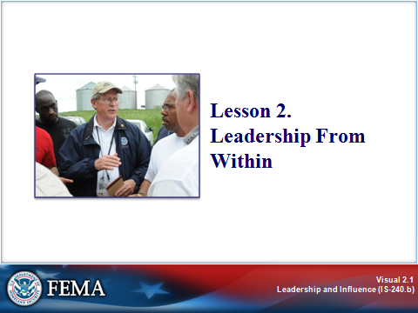
Key Points

This lesson focuses on leadership from within⎯the relationship between self-knowledge and effective leadership.

Part of being an effective leader is the ability to create an environment that encourages self-discovery and the testing of assumptions that may impede growth, change, and the development of a shared vision. As we work to increase self-knowledge, balance inquiry and advocacy, and solicit authentic feedback, we free ourselves⎯and our organization⎯to embrace constructive change.

INTRODUCTION
Visual 2.2

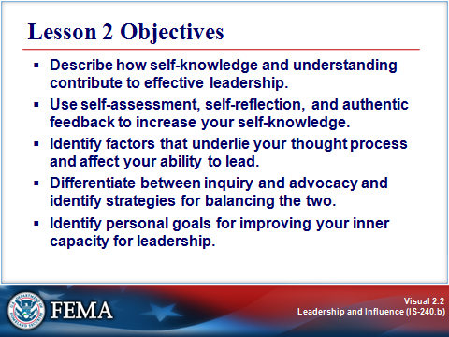
Key Points

After completing this lesson, you should be able to:

- Describe how self-knowledge and understanding contribute to effective leadership.
- Use self-assessment, self-reflection, and authentic feedback to increase your self-knowledge.
- Identify factors that underlie your thought process and affect your ability to lead.
- Differentiate between inquiry and advocacy and identify strategies for balancing the two.
- Identify personal goals for improving your inner capacity for leadership.

WHERE LEADERSHIP BEGINS
Visual 2.3

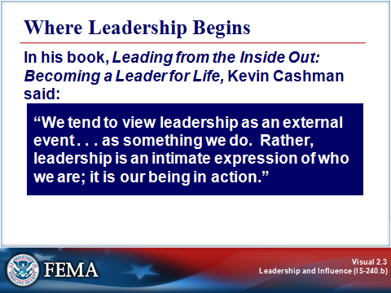
Key Points

We tend to think of leadership as telling others what to do instead of looking inside ourselves and thinking about how our leadership actions reflect who we are. Thus, instead of thinking, “What action should I take in this situation?” perhaps we ought to think more broadly and look at how our view of the world impacts our decisions, and how the messages that we send through our language and actions impact others.

PARADIGMS THAT GUIDE THINKING
Visual 2.4

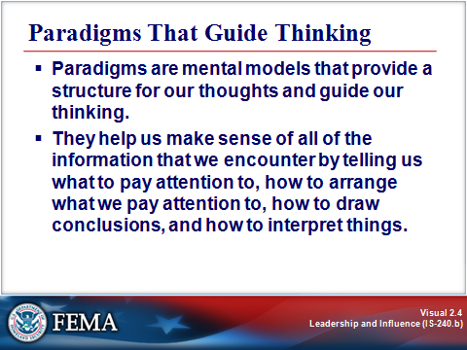
Key Points

The word paradigm tends to be overused, and it is often thought of as a “leftover” from the 1990s. Nonetheless, paradigms help us understand why people have different views of reality.

Paradigms are mental models that provide a structure for our thoughts and guide our thinking. They help us make sense of all of the information that we encounter by telling us what to pay attention to, how to arrange what we pay attention to, how to draw conclusions, and how to interpret things. This process is guided by a set of unconscious assumptions that we carry to make sense of what we experience.

We develop our paradigms over time from our family, region of the country, cultural niche, organizations⎯any environment in which we learn the written or unwritten rules that guide our behavior.

Paradigms are useful in that they help us structure how to think about and act in a situation. However, they cause problems when we think that our paradigm is the only paradigm. When we view people who have different paradigms as thinking in confusing, unpredictable, irrational, immoral, or unethical ways, our perspective and judgment frequently create conflict.

PARADIGMS THAT GUIDE THINKING
Visual 2.5

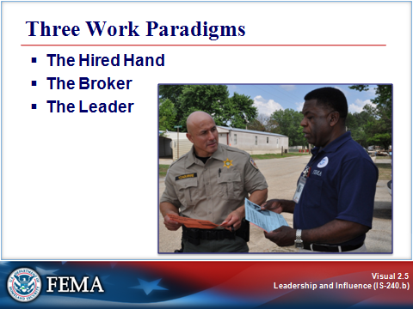
Key Points

We think of ourselves in many different ways at work. Sometimes we are focused on our work or the work of our immediate group. Sometimes we are trying to “get along” with others, and keeping things working as well as they can. Sometimes we have a broader vision of our place in our organization and our influence over it.

We can see these as three common work paradigms, and understand how each impacts our work and that of our entire organization. We will refer to the paradigms we will discuss as follows:

- The Hired Hand
- The Broker
- The Leader

We don’t work out of just one of these paradigms at a given time and for any given situation. These three paradigms complement each other, and we draw upon them based on our reaction to the situation at hand, and in order to address it.

The job aid on the next pages provides an overview of how operating out of each of these paradigms causes us to view and react to different aspects of our work. Those differences are then described on the following pages.

Job Aid: Three Work Paradigms

 | The Hired Hand | The Broker | The Leader
Sees Organization As . . . | A means of facilitating their work | A system of mutual interests that helps each other to achieve individual goals | People working together to achieve a greater goal
Source of Power . . . | Competence or perceived competence | Ability to manage interactions between others | Others trust in him/her
Perceives Senior Management As . . . | Bureaucratic, obstacle to progress | Granter of rights and privileges | Providing vision, direction
Handles Opposition  By . . . | Making logical, fact-based arguments | Making compromises to get what he/she wants | Listening to others, advocating his/her own position
Communication Style . . . | Stick to the facts | Tries to make sense of the facts | Understanding and being understood
Main Goal . . . | Advancing his/her work | Improving his/her position in the hierarchy | Define a vision and work toward achieving it

Sees the Organization as . . .

- The Hired Hand sees the organization as a means to an end. He/she wants to accomplish their work and need the organization to facilitate it. The barometers of the success of the organization, its leaders, and its employees is whether or not each completes the work they set out to do, and how well they do it.
- The Broker wants to accomplish his or her goals as well, but sees the organization as made up of smaller groups of individuals working together to achieve their own goals. Brokers judge the organization on how well its leaders and individuals interact and “cut deals” to get work done.
- The Leader sees the organization as made up of individuals working together to set and meet goals they couldn’t achieve by themselves. The ability to work effectively together, to make the sum greater than its parts, is the standard to judge the organization by.

Source of Power . . .

- The Hired Hand gets credibility from his or her ability to be the best at the job. The Hired Hand’s power is based both on technical competence and on how others view his or her competence (his or her reputation).
- The Broker’s credibility stems from his or her position within the hierarchy of the organization. Brokers who get things done are the most successful.
- The Leader’s credibility is based in his or her integrity and others’ belief in it. Leaders’ greatest asset is others’ trust in them. They wield their power to empower others.

Job Aid: Three Work Paradigms (Continued)

Perceives Senior Management As . . .

- The Hired Hand feels that in a perfect world, there would be no need for senior management. It produces nothing and gets in the way of progress.
- The Broker perceives senior management as a grantor of privileges and people to curry favor from. Being a member of senior management is a great honor since it allows the broker to make decisions that impact many.
- The Leader understands that senior management is there to lead and provide vision. Senior management should set the proper moral tone for the organization and “do the right thing”.

Handles Opposition By . . .

- The Hired Hand will engage in argument based on empirical evidence and fact. Hired Hands appeal to the rational in those that oppose them.
- The Broker works out of the “I’ll scratch your back if you scratch mine” school of conflict management. Compromises are made that provide what the Broker, and whomever the Broker is making deals with, to get what they want.
- The Leader strives to fairly address complex and competing needs in any situation, and thinks of creative, equitable solutions to any challenge.

Communication Style . . .

- The Hired Hand sticks to the facts – everything else is nonsense that distracts people from the true issue at hand.
- The Broker focuses on the facts but tries to make sense of them, ascribing meaning to create a big picture of what discrete events mean when considered together.
- The Leader realizes that humans look for meaning beyond the simple facts, and is sensitive to the perceived meaning of his or her actions. The Leader strives to understand others as well as be understood.

Main Goal . . .

- The Hired Hand wants to advance his or her own work and receive credit for it.
- The Broker wants to advance his or her work as well, but in this case it is his or her position within the hierarchy.
- The Leader is focused on defining and carrying out goals for the common good.

ACTIVITY: WHICH PARADIGM?
Visual 2.6

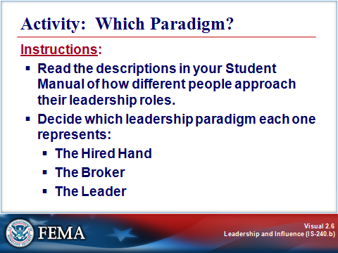
Key Points

Purpose: The purpose of this activity is to identify the different leadership paradigms.

Time: 5 minutes

Instructions: Read the following descriptions of how different people approach their leadership roles. Decide which leadership paradigm each one represents:

- The Hired Hand
- The Broker
- The Leader

Instructor Note: Give the participants 5 minutes to complete this activity. Ask for volunteers to share their responses.

ACTIVITY: WHICH PARADIGM?
Visual 2.6 (Continued)

Activity: Which Paradigm?

Instructions: Read the following examples of how different people approach their leadership roles. Indicate which leadership paradigm each one represents.

Examples of Approaches to Leadership Role | The Hired Hand | The Broker | The Leader
1. Jane is working toward an alliance with the smaller neighboring jurisdictions because she’s convinced that a comprehensive, cooperative response capability will best serve the citizenry. |  |  | 
2. Buck’s rank and seniority carry a lot of weight with his employees. He’s the boss, he knows the ropes, and he works hard. So they do, too. |  |  | 
3. Robert is convinced that the new Standard Operating Procedures (SOPs) just create a lot of busywork. No one at Headquarters has enough field experience to understand what really goes on. |  |  | 
4. The consensus among Jim’s employees and colleagues is that he is someone you can count on to be fair, principled, and beyond reproach. The new strategic plan seems a little scary to some, because it means a lot of changes, but he hasn’t let them down in the past. |  |  | 
5. Anna has locked horns with other response agencies over equipment resources. She decides to give in on the staffing issue to get access to the needed debris removal equipment. |  |  | 

ACTIVITY: WHICH PARADIGM?
Visual 2.6 (Continued)

Activity: Which Paradigm?

Instructor Answer Key

Examples of Approaches to Leadership Role | The Hired Hand | The Broker | The Leader
- Jane is working toward an alliance with the smaller neighboring jurisdictions because she is convinced that a comprehensive, cooperative response capability will best serve the citizenry.  The Leader’s main goal is to define and carry out a vision for the common good. |  |  | ☑
- Buck’s rank and seniority carry a lot of weight with his employees. He is the boss, he knows the ropes, and he works hard. So they do, too.  The Broker derives credibility and power from his/her rank within the hierarchy. |  | ☑ | 
- Robert is convinced that the new Standard Operating Procedures (SOPs) just create a lot of busywork. No one at Headquarters has enough field experience to understand what really goes on.  The Hired Hand sees senior management as an obstacle to progress. | ☑ |  | 
- The consensus among Jim’s employees and colleagues is that he is someone you can count on to be fair, principled, and beyond reproach. The new strategic plan seems a little scary to some, because it means a lot of changes, but he has not let them down in the past.  The Leader’s credibility is based in his/her integrity and others’ belief in it. Jim’s greatest asset is others’ trust in him. |  |  | ☑
- Anna has locked horns with other response agencies over equipment resources. She decides to give in on the staffing issue to get access to the needed debris removal equipment.  The Broker’s approach to opposition tends to be compromise⎯making deals to get what each party wants. |  | ☑ | 

BALANCING THE PARADIGMS
Visual 2.7

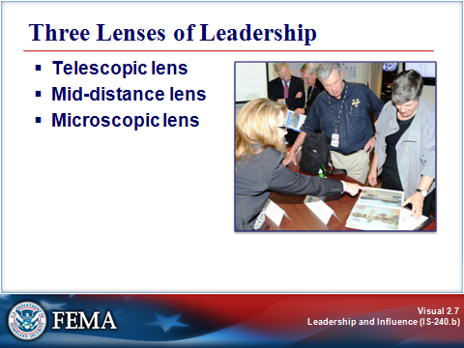
Key Points

We have examined three different ways of looking at the world. Is one right and the others wrong? Of course not. Everyone displays attributes of all three. However, those acting out of the paradigm of the Leader will be most effective and have the greatest impact over time.

In the final analysis, your paradigm is a way of thinking that guides your behavior, decisions, and actions. Given the complexity of the challenges you encounter as an emergency management professional today and in the future, you’ll want your thinking to be as multidimensional as possible.

Three Lenses of Leadership

The three paradigms will help you expand the range of your thinking. Think of them as three lenses through which to view a situation and determine your actions: the telescopic lens, the mid-distance lens, and the microscopic lens.

Telescopic lens. The telescopic lens has the longest term view. When you look through this lens, you’re more likely to:

- Establish your beliefs and values and be consistent with them.
- Determine a course for change in the future and articulate it as a vision.
- Stimulate coworkers and yourself to challenge traditional ways of thinking.
- Develop yourself and others to the highest levels of potential.

Mid-distance lens. When you look through the mid-distance lens, your view is focused on short-term goals. You’re likely to focus on articulating standards, expectations, goals, and rewards, and the consequences for not meeting expectations.

BALANCING THE PARADIGMS
Visual 2.7 (Continued)

Three Lenses of Leadership (Continued)

Microscopic lens. When you look through the microscopic lens, your view is like that of the individual contributor. You may be part of a task force or team where your focus is on detail-oriented, task-specific work and your style is more laid back.

For most of us, growing as a leader requires us to become aware of our paradigms and develop the ability to view situations through the three lenses just described.

Using All Three Lenses

Changing old ways. When using all three lenses, you may need to let go of behaviors and beliefs about leadership that are comfortable for you but that no longer serve you well. You may have to stop doing some things you’re good at and love to do, and instead delegate them to someone else to further that person’s professional development. Or, you may begin to rethink behaviors that haven’t served you well and consider how to change them.

Benefits. Moving away from old habits and out of your comfort zone can free you to expand the ways in which you think about leadership, change your behaviors and actions to become more effective, and move freely between the paradigms through more conscious choices.

SELF-KNOWLEDGE
Visual 2.8

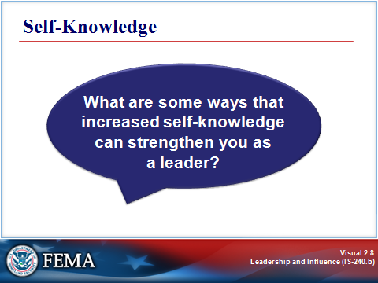
Key Points

The first step in this process of leadership growth is developing self-knowledge. Self-knowledge is an awareness of our internal feelings, preferences, biases, strengths, and weaknesses.

What are some of the ways that increased self-knowledge can strengthen you as a leader? Take a few moments to jot your ideas in the space below.

Self-knowledge can make me a stronger leader in the following ways:

SELF-KNOWLEDGE
Visual 2.9

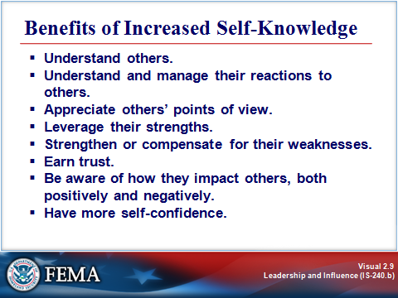
Key Points

Self-knowledge is a common trait among great leaders. Effective leaders tend to look inside themselves. They are centered, have an internal locus of control, and exhibit self-understanding and self-confidence. Most leaders find that increased self-knowledge helps them:

- Understand others.
- Understand and manage their reactions to others.
- Appreciate others’ points of view.
- Leverage their strengths.
- Strengthen or compensate for their weaknesses.
- Earn trust.
- Be aware of how they impact others, both positively and negatively.
- Have more self-confidence.

Instructor Note: Ask the following question: Can anyone add other benefits of increased self-knowledge?

SELF-KNOWLEDGE
Visual 2.10

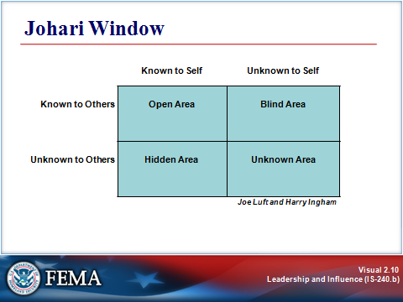
Key Points

Source: Joe Luft and Harry Ingham. “The Johari window, a graphic model of interpersonal awareness,” Proceedings of the Western Training Laboratory in Group Development. Los Angeles: UCLA, 1955.

The Johari Window is a model that provides us a visual way to think about self-knowledge.

This model delineates four quadrants involved in interpersonal relationships:

- The Open Area is what we both know about me and openly share.
- The Hidden Area is what I hide from you about myself.
- The Blind Area is what you know about me—what you keep from me, what you observe about me, or think or feel about me, of which I am unaware.
- The Unknown Area is part of me, from my past, about which neither one of us yet knows, at least on a conscious level.

SELF-KNOWLEDGE
Visual 2.11

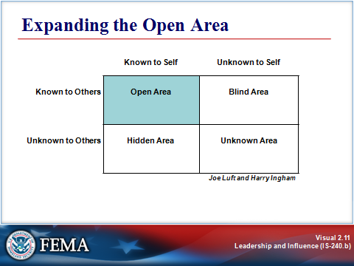
Key Points

The more we can increase the parts of ourselves that are known to self and others, the greater our potential for building effective relationships, both at home and in the workplace.

Benefits. You’ve already considered some of the benefits of increasing the area that you know about yourself. But increasing what others know about you is one of the most important things you can do to build trust with those you lead.

When leaders make their reasoning and thinking apparent to others, they build trust over time. As a result, others are then more willing to give them the benefit of the doubt during those times when the leader can’t share information.

Opening Up. Becoming more open means showing people more of your thinking, more of the things that you are wrestling with, more about your objectives, and your likes and dislikes with respect to the “business” of emergency management. It means making yourself more available. (Remember, though, we’re talking about work-related issues, not personal issues.)

Think about leaders you have worked with before. Have the leaders you really trusted and respected been more open about themselves than other leaders? Did they let you in on their preferences, biases, strengths, and weaknesses with respect to work issues?

While being more open involves some risk, the potential payoff is greater trust, understanding, and the benefit of the doubt when it’s needed.

SELF-KNOWLEDGE
Visual 2.12

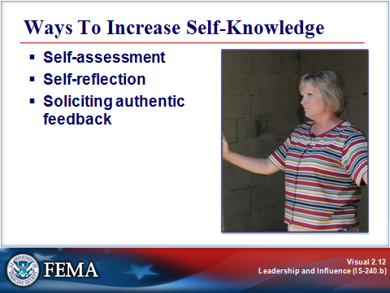
Key Points

Whether or not you consider yourself a self-aware person, there are many ways to learn more about yourself and how you lead. Three important methods include:

- Self-assessment.
- Self-reflection.
- Soliciting authentic feedback.

SELF-KNOWLEDGE
Visual 2.13

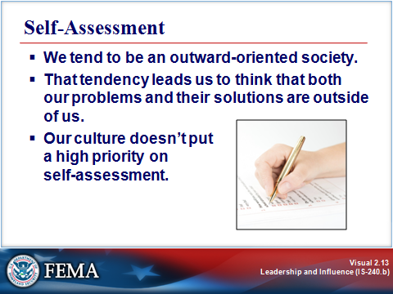
Key Points

We tend to be an outward-oriented society. That tendency leads us to think that both our problems and their solutions are outside of us. Our culture doesn’t put a high priority on self-assessment.

Significance. The upside of this is that we become good at recognizing and analyzing the world outside ourselves. But the downside is that we tend to overlook the ways in which we ourselves are impacting the world around us. We tend to be less aware of the choices we make, our own responses to situations, and our own resources that can help us succeed.

Our outward orientation can blind us to perhaps our most important and readily available resources: our own talents, preferences, and choices.

Approaches. In the previous lesson, you completed a simple self-assessment that focused on proficiency and time spent on various leadership activities. You can repeat that assessment from time to time to maintain awareness of your leadership skills and growth.

Another approach is to get others to rate you using the same instrument. This will give you an idea about the degree to which your view of yourself is aligned with how others see you.

If you develop self-assessment as a habit, over time you will be able to see yourself with greater honesty and accuracy.

SELF-KNOWLEDGE
Visual 2.14

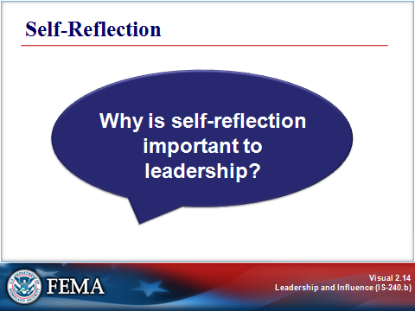
Key Points

Self-reflection is another method for increasing self-awareness. Self-reflection is the ability to “hit the pause button” and critically assess yourself or a situation.

Importance. Why is self-reflection important to leadership?

- Self-reflection helps you ensure that you are taking sound actions and not simply running on “auto pilot,” but rather are conscious about doing what is most important in any given situation.
- Self-reflection can help you learn from your experience⎯to avoid the trap of simply repeating things that aren’t working.
- Self-reflection allows you to notice your habitual ways of responding so that you have the option of approaching things differently.

Methods. There are many ways to reflect, and some methods may work better for you than others. One approach is just to take a short timeout in which you simply stop and think. Other approaches include:

- Journal writing.
- Note taking.
- Talking to others (thinking out loud).
- Speaking into a tape recorder.
- Meditation.
- Drawing pictures.

The job aid on the next page provides guidelines for two of these methods: journal writing and thinking out loud. Give them a try⎯either now or later, after you have finished this course.

Job Aid: Self-Reflection Techniques

Journal Writing

Journal writing is one technique for self-reflection. Approached in the right way, it can be a process of discovery rather than mere reporting. Productive journal writing takes very little time and can be of great benefit. It can be a powerful tool for reflection, self-discovery, problem solving, learning, and integration. Here’s how it works:

- Think about a situation at work with which you are currently struggling or feeling unsettled. (This technique is also good for situations in your personal life.)

- Write down a set of questions you want to reflect on concerning the situation. Put each question on a separate page, to allow room to write. For starters, try these questions:

- What about this situation is uncomfortable or difficult for me?
- What did I learn about myself and/or the situation?
- What are all of the possible steps I can think of to take, based on what I’ve just learned?

As you become familiar with this technique, you can vary the questions to accommodate your own needs for personal growth.

- Decide on a time limit (for example, 3 minutes per question). If possible, set a timer so you don’t have to watch the time.

- Begin writing. Write about the first question continuously for the allotted time. Write whatever comes to your mind. Don’t worry about grammar or punctuation. Just do not stop writing until the time is up.

- Respond in the same manner to each question, timing yourself and writing continuously.

Try journal writing every day for a week before deciding whether this approach works for you.

Thinking Out Loud

Thinking out loud is another self-reflection technique. It is quite simple and can be done with a partner or alone, using a tape recorder. These are the ground rules:

- The partner has only one role: to listen. He or she should not provide suggestions, advice, or insert himself or herself at all in the speaker’s process.

- Select a situation with which you are currently struggling or feeling unsettled, to talk about.

- You may wish to set up a timeframe in advance (e.g., 1 minute to set the context and 4 minutes to speak).

- Talk.

- Afterwards, review what you said. Either discuss it with your partner or replay your tape. Many people find that having a “sounding board”—someone to listen without trying to solve their problem—unleashes their creative problem-solving abilities.

ACTIVITY: SELF-REFLECTION
Visual 2.15

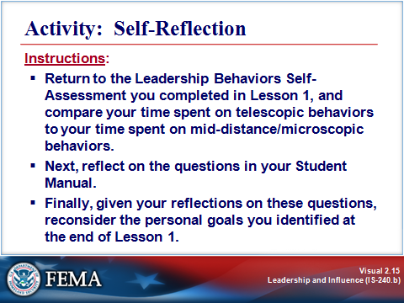
Key Points

Purpose: The purpose of this activity is to reflect on your leadership behaviors.

Time: 10 minutes.

Instructions:

- Return to the Leadership Behaviors Self-Assessment you completed in Lesson 1, and compare your time spent on telescopic behaviors to your time spent on mid-distance/microscopic behaviors, as explained on the following page in your Student Manual.
- Next, reflect on the questions in your Student Manual.
- Finally, given your reflections on these questions, reconsider the personal goals you identified at the end of Lesson 1.

Instructor Note: Give the participants 10 minutes to complete this activity. Ask for volunteers to share their responses.

ACTIVITY: SELF-REFLECTION
Visual 2.15 (Continued)

Self-Reflection: Looking at How You Spend Your Time

Notice that the first eight items on the Leadership Behavior Self-Assessment relate to telescopic behaviors, and the last seven relate to mid-distance and microscopic behaviors.

Step 1: Total your telescopic and mid-distance/microscopic proficiency scores (column one) and percentages (columns two and three), and enter them below.

 | How proficient are you in this behavior?  Rate from 1 to 10:  1 = No Proficiency  10 = Full Proficiency | How much time do you spend on this behavior?  Estimate the numeric percentage of your time spent on each. | For your group to excel, how should you apportion your time?  Express the numeric percentage of time you should spend on each.
Telescopic behaviors
(Add up the individual scores and percentages for items 1-8.)
Mid-distance and microscopic behaviors
(Add up the individual scores and percentages for items 9-15.)

Step 2: Next, reflect on the following questions:
- What observations can you make about how your time and abilities differ between the telescopic and midrange/microscopic behaviors?

- Do these observations make you think differently about your role as a leader? If so, explain.

- For your organization or work group to excel, what specific shifts do you need to make in how you spend your time? How will you make these shifts?

- What skills do you need to strengthen to lead your organization or work group to excellence? How might you go about strengthening those skills?

Step 3: Finally, given your reflections on these questions, reconsider the personal goals you identified at the end of Lesson 1. Do you wish to adjust them or add others at this time?

AUTHENTIC FEEDBACK
Visual 2.16

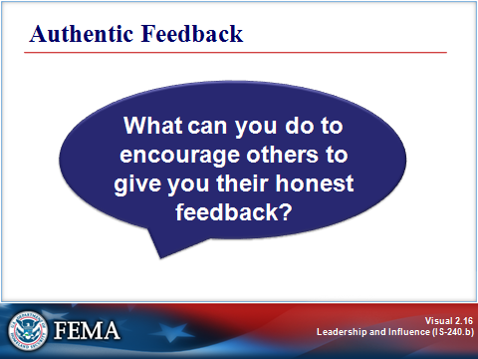
Key Points

The third technique for increasing self-knowledge is soliciting authentic feedback from others. Leaders who know themselves and let others know them are those who earn the respect and trust of their colleagues. Soliciting feedback is one of the most effective methods for increasing the open area of the Johari Window, “Known to Self and Others.” Feedback is critical to self-knowledge and thus, your ability to lead. It helps you to know if you are leading in ways that are effective for those whom you lead.

Feedback can be informal. We usually think of feedback as a formal process that happens once or twice a year. But you don’t have to wait for a formal process to get feedback. In fact, the more informally and frequently you get feedback, the better. It is vital to ask for and receive feedback in a way that encourages others to tell us the truth as they see it.

Feedback requires trust. People may be reluctant to give you honest feedback if they don’t trust you. That willingness to be honest is built on trust that develops over time. And to some extent, most of us have a tendency⎯usually unconscious⎯to do things that inhibit others from giving us truthful feedback. Down deep, we may not really want the truth.

What can you do to encourage others to give you their honest feedback? On the next page are some tips for encouraging authentic feedback.

AUTHENTIC FEEDBACK
Visual 2.17

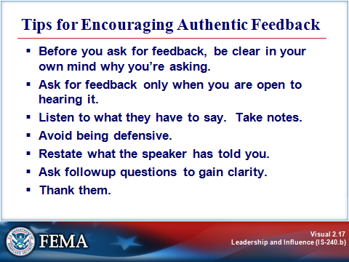
Key Points

Before you ask for feedback, be clear in your own mind why you’re asking.

- Ask for feedback only when you are open to hearing it.
- Listen to what others have to say. Take notes.
- Avoid being defensive. Don’t try to explain yourself during the feedback process.
- Restate what the speaker has told you, to make sure that you understand what was said.
- Ask followup questions to gain clarity; get specifics. For example:
- “Can you give me some specifics?”
- “What impact is that having?”
- “Can you tell me more about that?”
- Thank the individual(s) who gave you the feedback.
- When possible, make changes as a result of the feedback.
- Initially, ask for feedback infrequently until others see that you’re willing to make changes based on earlier feedback given to you. Remember that you need to build trust in the fact that you really want to hear what they have to say and that you will do something to change.

Remember, those acting out of the Leader paradigm are leaders of change. The best way you can model to others that change is welcome is to grow and change yourself. Soliciting feedback is one of the best ways to show the people you lead that you are open to input and willing to change. Then, take action on the feedback that you feel is valid.

You are not required to adopt every bit of feedback that people give you. But try thinking about feedback as similar to the gifts you receive for your birthday. To some of them, you’ll say, “YES! GREAT!” To others, you’ll say, “Thank you,” and put them in your closet. Nevertheless, you will benefit more if you stay open to all of the feedback, consider it carefully and with an open mind, and incorporate what seems valid.

AUTHENTIC FEEDBACK
Visual 2.17 (Continued)

Use the job aid on the following page to identify people from whom you can solicit authentic feedback about your leadership. They may be subordinates, those with more authority than you, peers, or others. If possible, try to identify people who can offer different perspectives on your leadership.

Jot down notes about your feedback strategy⎯e.g., good situations in which to invite each person’s feedback, timing, lead questions, areas of your leadership you hope to learn more about from this person, and so on.
Job Aid: Authentic Feedback

Instructions:

- Identify at least three people from whom you can solicit authentic feedback about your leadership. They may be subordinates, those with more authority than you, peers, or others. If possible, try to identify people who can offer different perspectives on your leadership.

- Jot down notes about your feedback strategy⎯e.g., good situations in which to invite their feedback, timing, lead questions, areas of your leadership you hope to learn more about from this person, and so on.

Feedback Source #1: _______________________________________________

Strategy:

Feedback Source #2: _______________________________________________

Strategy:

Feedback Source #3: _______________________________________________

Strategy:

UNDERSTANDING HOW YOU THINK
Visual 2.18

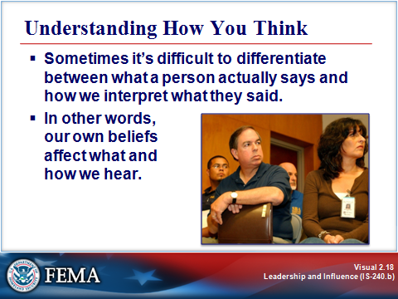
Key Points

The preceding section noted the importance of receiving feedback without explaining or defending yourself. Have you ever noticed what happens when you really listen to another person without intending to respond? Perhaps not, because most of us listen only rarely. Usually what we hear is received through many filters, including:

- Assumptions and biases.
- Resistances and barriers stemming from a different set of beliefs.
- Preoccupation with identifying areas of agreement with our own beliefs, and the significance of such agreement.
- Thinking about how we will respond.

Sometimes it’s difficult to differentiate between what a person actually says and how we interpret what they said. In other words, our own beliefs affect what and how we hear.

UNDERSTANDING HOW YOU THINK
Visual 2.19

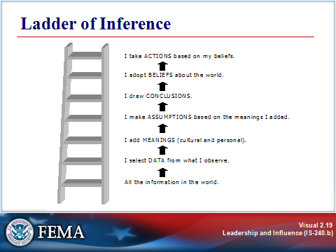
Key Points

Source: Peter M. Senge. The Fifth Discipline: The Art and Practice of the Learning Organization. New York: Currency Doubleday, 1994.

Business theorist Chris Argyris developed a model that explains our thinking process as we interact with the world, and Peter Senge applied the model in his work on learning organizations. This seven-step process, called the Ladder of Inference, is illustrated on the following page. According to this model, as we move up the ladder our beliefs affect what we infer about what we observe, and therefore become part of how we experience our interaction with other people.

UNDERSTANDING HOW YOU THINK
Visual 2.19 (Continued)

Ladder of Inference

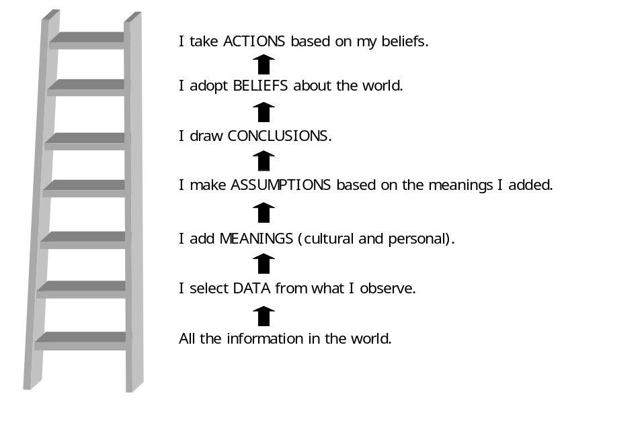

Source: Peter M. Senge. The Fifth Discipline: The Art and Practice of the Learning Organization. New York: Currency Doubleday, 1994.

An obvious example of how the Ladder of Inference impacts our actions would be only “hearing” that which supports your own argument. But the process is usually much more subtle. Your background influences the meanings that you ascribe to what you hear, which in turn leads you to make assumptions. In fact, your beliefs affect which data you select in the first place.

If you take the time to “walk” up and down the Ladder of Inference, you can learn a great deal about how your own beliefs, assumptions, background, culture, and other influences (i.e., your own personal paradigm) affect how you interpret what others say and how you interact with them. It is also a useful tool for reaching a better understanding of those you lead.

CREATING A LEADERSHIP ENVIRONMENT
Visual 2.20

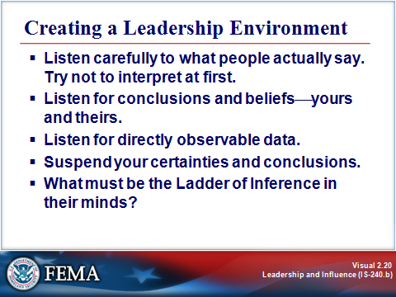
Key Points

As discussed earlier, one approach that fosters an environment of leadership is soliciting authentic feedback and responding to that feedback with openness to change. The Ladder of Inference is also a useful tool for creating a leadership environment.

Using the Ladder of Inference to Create an Environment of Leadership

As you interact with other people, try walking down the ladder to gain a better understanding of how you⎯and they⎯think.

- Listen carefully to what people actually say. Try not to interpret at first.

- Listen for conclusions and beliefs⎯yours and theirs.
- Do they jump to conclusions?
- What conclusions are you making as you listen?

- Listen for directly observable data.
- Can you form a picture in your mind of what they are saying?
- Ask yourself: What led them to think as they do?

- Suspend your certainties and conclusions.
- Do they act as if their conclusions are obvious?
- Do you?
- Are there other ways of seeing things?

- What might be the Ladder of Inference in their minds?

CREATING A LEADERSHIP ENVIRONMENT
Visual 2.21

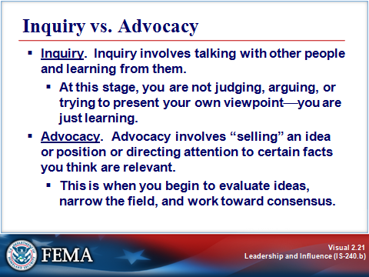
Key Points

What happens when you sit down with another person or a group of people and discuss something (an issue, a plan, a goal, a problem)? A healthy discussion will include first inquiry, then advocacy.

- Inquiry. Inquiry involves talking with other people and learning from them. At this stage, you are not judging, arguing, or trying to present your own viewpoint⎯just learning. During this phase you should strive not only to hear the other person’s words, but to learn about their mental models to understand where they are coming from and what they are really saying.

The inquiry stage is also a time for observing your own thoughts, checking out your Ladder of Inference. Inquiry requires that you suspend assumptions. This does not mean laying them aside, but rather bringing them forward and making them explicit so that you and the others can explore their meaning and impact.

- Advocacy. A second aspect of communication, after the inquiry stage, is advocacy. Advocacy involves “selling” an idea or position or directing attention to certain facts you think are relevant. This stage is when you begin to evaluate ideas, narrow the field, and work toward consensus.

In a team context, inquiry and advocacy are sometimes called dialogue and discussion. During the dialogue phase, everyone should be in an inquiry mode⎯sharing facts, ideas, and opinions, without evaluating or defending them. By the time you move to the discussion phase, everyone should have a common understanding of all of the facts and viewpoints. Then comes discussion, when you try to determine what you believe in. The problem in many teams is that they tend to move too quickly to discussion, without adequate inquiry. This practice has the effect of stifling creative thinking and undermining trust.

CREATING A LEADERSHIP ENVIRONMENT
Visual 2.22

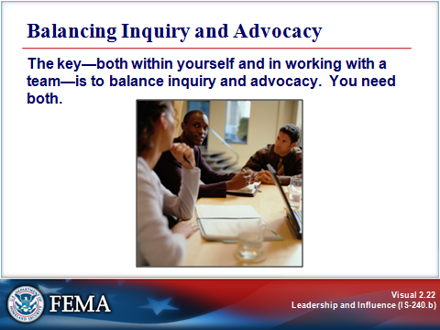
Key Points

The key⎯both within yourself and in working with a team⎯is to balance inquiry and advocacy. You need both. In your efforts to develop self-knowledge, be aware of your intentions behind your inquiry and advocacy, and strive to balance the two. Then, work to enable your group to do the same. The job aid on the next page provides some tips for balancing inquiry and advocacy.
Job Aid: Tips for Balancing Inquiry and Advocacy

- Become aware of the gap between what you intend and what you actually do. Notice other people’s reactions to you: Are the reactions what you expected? Why or why not? Make an effort to understand and begin to close this gap.
- Let go of the win/lose mindset of controlled discussion. Decide to learn from others.
- Make your thinking visible, and ask others to do the same. State your assumptions, explain your reasoning, and give examples.
- Avoid defensiveness when your ideas are questioned.
- Be aware when you or others are jumping to conclusions.
- Gently walk others down the Ladder of Inference and find out what data they are operating from. Use unaggressive language (e.g., “Can you help me understand your thinking here?”).
- Listen without resistance. Hear ideas as if for the first time.
- Respect differences.
- Suspend role and status during dialogue; let leadership become a shared responsibility of the whole group.
- Try to bring forward people who have not spoken, and prompt them to add their views.
- Take risks by participating and being willing to make mistakes. Speak from your own experience.
- When advocating, stay open and encourage others to give different views
.
- If you notice that a discussion is lopsided, let the group know what you’ve observed. Help the group to balance inquiry and advocacy by making your own contributions in a way that creates more balance.

ACTIVITY: YOUR INNER LEADER
Visual 2.23

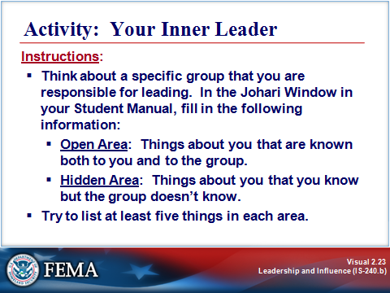
Key Points

Purpose: The purpose of this activity is to identify the Open Area and the Hidden Area of yourself as a leader.

Time: 10 minutes

Instructions:

- Think about a specific group that you are responsible for leading. In the Johari Window on the next page, fill in the following information:

- Open Area: Things about you that are known both to you and to the group.
- Hidden Area: Things about you that you know but the group doesn’t know.

- Try to list at least five things in each area.

Instructor Note: Give the participants 10 minutes to complete this activity. After 10 minutes, move to the next part of the activity.

ACTIVITY: YOUR INNER LEADER
Visual 2.23 (Continued)

Activity: Your Inner Leader
Using the Johari Window

 | Known to Self | Unknown  to Self
Known to Others | Open Area: Write your responses here: | Blind Area
Unknown to Others | Hidden Area: Write your responses here: | Unknown Area

ACTIVITY: YOUR INNER LEADER
Visual 2.24

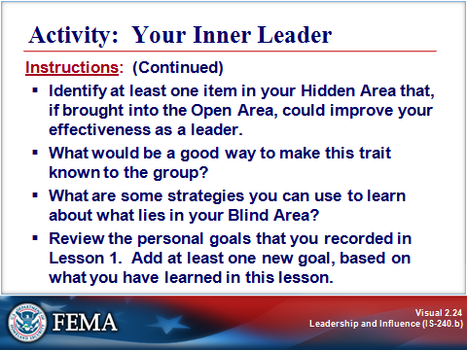
Key Points

Purpose: The purpose of this activity is to expand your effectiveness as a leader.

Time: 10 minutes

Instructions: Based on the information you inserted in the Johari Window, answer the following questions:

- Identify at least one item in your Hidden Area that, if brought into the Open Area (i.e., making it known to the group), could improve your effectiveness as a leader.

- What would be a good way to make this trait known to the group?

- What are some strategies you can use to learn about what lies in your Blind Area?

- Review the personal goals that you recorded in the first lesson. Add at least one new goal, based on what you have learned in this lesson.

Instructor Note: Give the participants 10 minutes to complete this activity. Ask for volunteers to share their responses.
SUMMARY AND TRANSITION
Visual 2.25

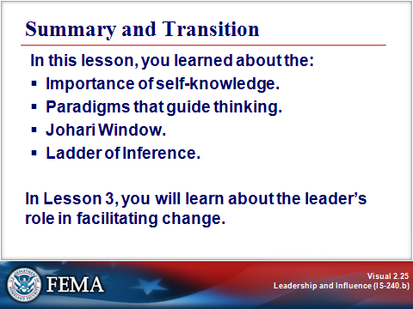
Key Points

In this lesson, you learned about the:

- Importance of self-knowledge as a resource for effective leadership.
- Paradigms that guide thinking, specifically, three leadership paradigms: the Hired Hand, Broker, and Leader paradigms.
- Johari Window as a visual way to think about self-knowledge, and explored ways to increase self-knowledge through self-assessment, self-reflection, and soliciting authentic feedback.
- Ladder of Inference and its relationship to inquiry and advocacy, and reviewed strategies for balancing inquiry and advocacy.

In the next lesson, you will learn about the leader’s role in facilitating change.

For More Information:

- FEMA EMI Independent Study Course IS-242: Effective Communication

- Search keywords:
- Leadership in organizations
- Traits of managers and leaders, leadership trends
- Mental models

This page intentionally left blank.

